https://www.jdoodle.com/embed/v0/61DS
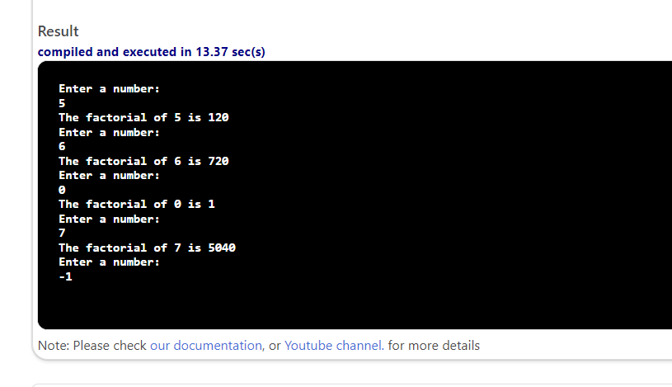

#include <iostream>
using namespace std;
int main()
{
int num;
cout << "Enter a number: " << endl;
cin >> num;
while (num >= 0)
{
int factNum = 1;
for (int i = 1; i <= num; i++)
{
factNum *= i;
}
cout << "The factorial of " << num << " is " << factNum << endl;
cout << "Enter a number: " << endl;
cin >> num;
}
return 0;
}

